Founder SuperLine™
DEMO SCRIPT
Anti-Counterfeiting Design System
Key Features:
- Guilloche
- Texture
- Microtext
- Engraving
- Lace
- Refraction
- Lock-opening
- Latent
- Rasterization
- Relief
- Bar code
- Split Line (available outside of Europe and USA.)

[Show the rolling demo of SuperLine.]

Any specific points you would like me to cover about Founder’s security pattern software SuperLine?

[Write down the questions and will make sure review before end of the demo]

Here I will briefly demo Founder’s anti-counterfeiting security design system; it will take about 10 minutes.

Okay. So what is SuperLine? What does it do?

What is SuperLine?

Founder SuperLine Anti-Counterfeit Design System is digital design software for security against counterfeit and forgery of almost any printed item.

Founder SuperLine performs anti-counterfeiting in the design process and, unlike other anti-counterfeiting solutions, implements the security elements in the printing process without incurring the additional cost of traditional solutions.

It creates a range of effects for different applications, including guilloche, relief, microtext, lace and latent. It also offers lock-opening, wave-filtering, and variable line widening technologies to meet special needs.

These powerful functions make it very easy to generate complicated patterns only with a few mouse clicks. Next, I am going to walk you though some of our key functions in the SuperLine which will take your breath away!

SuperLine’s target market is the creation of secure printed documents such as packaging, lottery products, certificates and brand protection. There are several installations where SuperLine is being used to create lottery products.

Sample Review

Now let’s check out the samples of SuperLine. The idea is to let you see the various shapes and patterns Founder SuperLine can generate to guard against counterfeit and forgery. These patterns include Guilloche, Texture, Filter, Microtext, Engraving, and so on.

Show real job samples brought from China and Latin America.

Process Chart

Demo Sample Jobs

Next, I am going to show you one of the patterns in the sample book on my computer screen and let you see the security effects SuperLine generates.

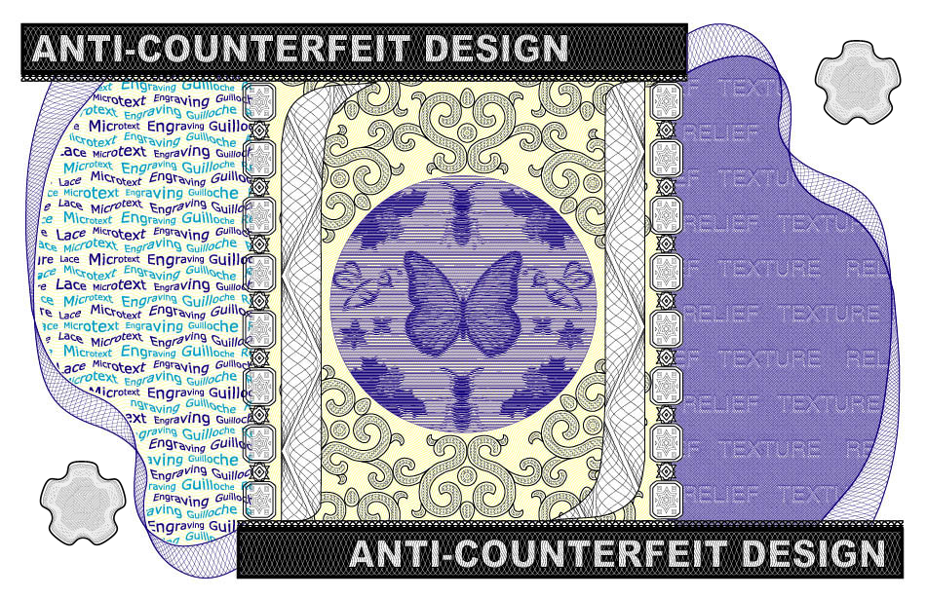

[Please zoom in the Coupon image for close-up on: Microtext and filter (left hand side); Relief and Texture (right hand side); Image relief and engraving (in the middle), and Guilloche (bottom left hand side and top right hand side)]

You can also see the guilloche generated by SuperLine in the cover of brochure,

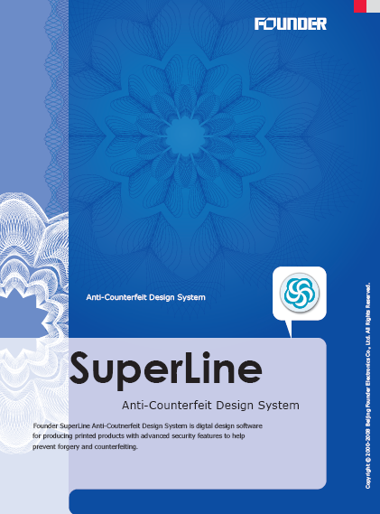

I am going to show you how to produce this flowery pattern with numerous lines on the cover in just a few clicks.

A. Guilloche

Now I have prepared a flowery pattern before the demo and all I have to do is to set the parameter.
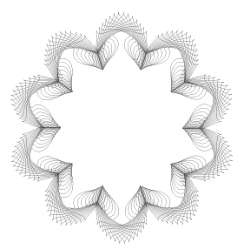
- Ungroup the objects, then Select 2 curves, then select Effect->Wave Generator, select F22 in the Function list, 10 in Density, 20 in Period, 70 in Phase Coverage, 18 in Phase Offset, every time when you change the parameter, you can click preview to see the effect.
- Click Generate, and you can get the guilloche.
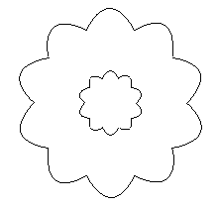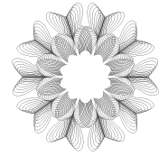
- Select 2 curves, then select Effect->Wave Generator, set the same parameters, select F22 in the Function list, 10 in Density, 20 in Period, 70 in Phase Coverage, 18 in Phase Offset, every time when you change the parameter, you can click preview to see the effect. Select (check) Original Curve.
- Click Generate, and you can get the guilloche.
- Put them together, center align, now you can get the final guilloche.
- Select the pattern, by accurate display to show the effect.
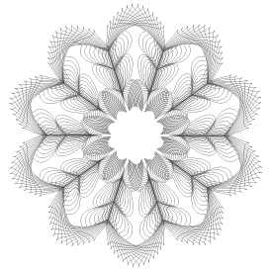

Features

Besides guilloche, Founder SuperLine has a host of other patterns including:
- Microtext | - Engraving
- Lace | - Bar Code
- Fractal | - Refraction
- Relief | - Lock-opening
- Filter | - Rasterization
- Latent | - Texture

Benefits

SuperLine is an advanced software solution which integrates the latest Founder Electronics’ core technology, and is aimed at companies that produce the packaging and printing for any product or document that is vulnerable to counterfeit copying - which might include copyright digital images.

SuperLine software will also protect legal documents from reproduction by devices such as photocopiers, laser printers and scanners. However, because the line frequencies can be changed or modified to meet lower resolutions, devices such as digital presses are able to reproduce anti-counterfeiting designed documents. They would be able therefore to print secure work such anti-counterfeit limited edition pictures, posters, video sleeves or CD labels – and also protect images delivered over the internet.

For OEM partners, SuperLine is targeted at organizations that value security, or design security documents such as packaging, banknotes, certificates and licenses, and for the packaging of goods that have a brand value. The SDK is now available for integration into OEM products. SuperLine technology can add value to OEMs products, such as digital printers and copiers.

Review & Summary

- Superior price/performance: high end solution at competitive price
- Enhanced various security elements
- Robust design and layout functionality
- Ease-to-use GUI similar to popular page layout software
- Modularized SDK available for OEM

Then let’s check all the questions we have.

[Review the questions you wrote down and make sure you will answer all the questions, if not bring the colleagues who can help]

OK, Ladies and Gentlemen, I do appreciate your time for being patient to take this quick tour of SuperLine, Founder’s anti-counterfeiting security design system.

We will be more than happy for further discussions. I wonder when and where we can make the next appointments? Who in your organization may be interested to this system? I appreciate if you would invite them to have a look here or let me know the contact info so I will send relative information to.

[Write down next step appointments and all contact information.]

Any questions?

[Q&A session if any]

Have a great day!

[After visitors leave stand, delete all intermediate files generated during this demo, clear up to make sure it’s exactly same environment ready for next demo.]

[Make necessary notes to complement this demo and hand it to booth captain to record the information for further actions.]

-- End of Demo --

Appendix: FAQ

Installation Status

We have over tens of dozens of installations in China. The Chinese version of Founder SuperLine™ was released in 1999 to the domestic market. Up to date, SuperLine™ has become the dominant prepress anti-counterfeiting design system in China, where numerous high-end packagers and commercial printers are working with SuperLine™ on their daily productions.

Additional Demo

Please refer to the instructions below for additional demo, if requested.

B. Texture

In SuperLine, texture that looks very complicated can be created very quickly and easily because SuperLine offers many copy tools.

- Select File->Import, Select “Texture.blk”
- Same as the guilloche, the left graphic is the one I am gonna produce.
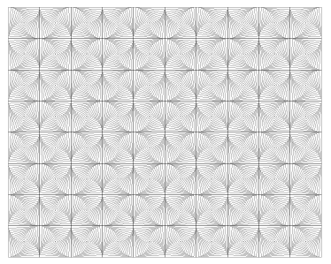
- Firstly, create a unit.
- Draw 2 rectangles. One is larger and the other is smaller.
- Click Effect->Blend; select the start object and the end object. Enter the steps [10] and the rotating angle [45]; you can easily make a group of curves.
- Select all the objects and make them group.
- Copy the group object and paste, mirror one of them horizontally. Align these 2 objects central and adjacent horizontally. Make these curves group.
- Using same method, form the basic item.
- Finally, click Array in matrix [4*5], and then you are done.
- Select the pattern, by accurate display to show the effect.

C. Filter

Graphic can be distorted by filter function. SuperLine offers several filter functions. The fish-eye is one of them.

- Select File->Import, select “Filter.blk”
- The left graphic is the fish-eye effect.
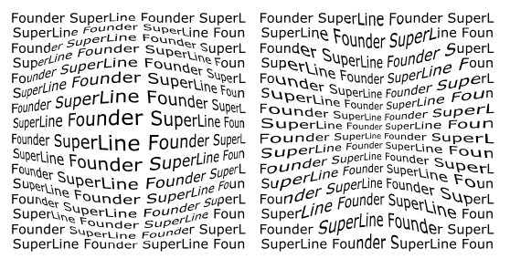
- Firstly, prepare many texts like this. You should convert these texts into curves.
- Secondly, click Effect->Fish Eye, and then open the Fish Eye dialogue box.
- Select a region from through which you want to transform these texts. Set appropriate value in the coefficient item, and then Apply.
- As you can see, the text graphic looks like convex or concave. You can control the convex or concave effect by changing coefficient.
- Select the pattern, by accurate display to show the effect.

D. Microtext

Microtext is also among SuperLine functional modules to guard against counterfeit.

- Select File->Import, select “Microtext.blk”
- The left is the microtext based on guilloche.

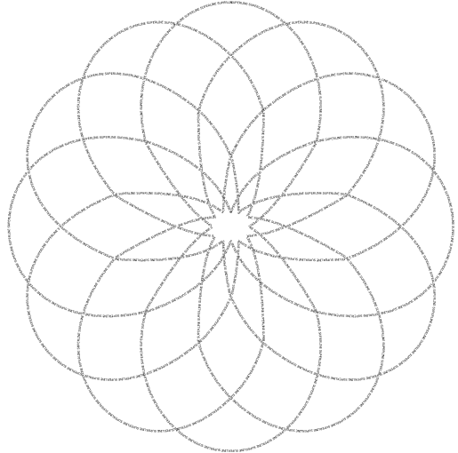

- Select the guilloche that we already made, click "Array text along curve", and input the text. You can define the gradient text in this dialogue box.
- Click OK, a microtext is created in a second. You can tell how fast and easy to create a microtext by SuperLine.
- Select the pattern, by accurate display to show the effect.

E. Engraving

SuperLine has many functions processing images such as engraving. It uses lines to simulate the levels of image.

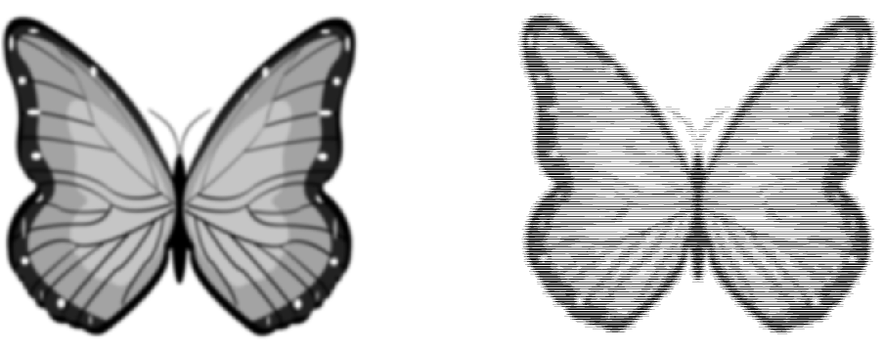

- Select File->Import, select “Engraving.blk”
- Prepare a group of curves as the same size as the image.
- Align centrally the curves and the image, and select both of them.
- Click Image->Engraving on Image, and then open the engraving dialogue box. You can input the maximum and the minimum line width. They can be defined as your wish.
- Click OK, then you’ll produce the engraving effect. The more dark the image changes, the more thick the line becomes [Max Width: 0.25mm, Min Width: 0mm, Precision: 0.05mm].
- Select the pattern, by accurate display to show the effect.

F. Split Line [Optional]

A line can be split into several roots or sublines like this.

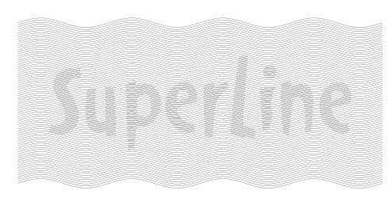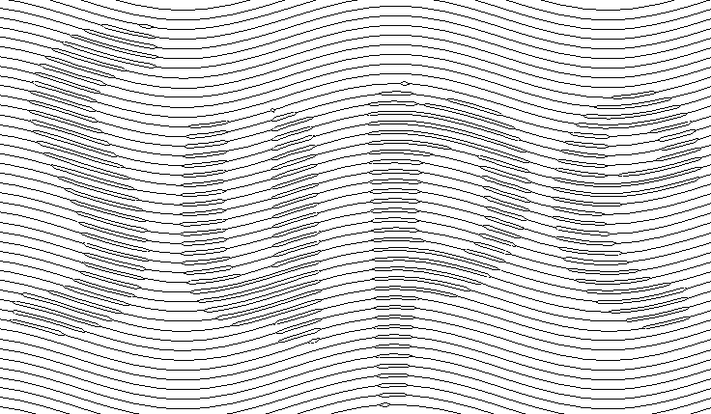

- Select File->Import, select “SplitLine.blk”
- I have prepared two graphics. One is text like "Superline", the other is a group of curves.
- Select the two graphics at the same time. Open the menu "Relief on Split Line", input the value where appropriate, click OK, you can see the effect of split line. You can see a single line has been divided into several roots. You can also change the value you input, and you'll get different effect.(Height: 0.1, Number: 2, Gradient: 0.25)
- Select the pattern, by accurate display to show the effect.

