What’s new in ElecRoc v5.11
- Mac client of ElecRoc v5.11 supports Mac OS 10.7.2.

- Add a new imposition module (Imposer II).

- Imposer II runs both on PC and Mac, supporting template edition.

- Imposer II supports printing types of Sheetwise, Work and Turn, Work and Tumble, Perfector.
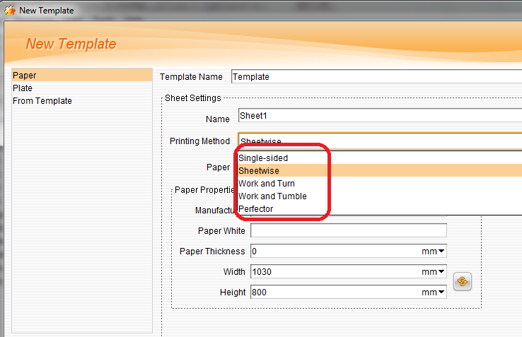

- Add check items in preflight, which spot color is embedded with overprint property, or with transparence property. According to the general rules, if spot color converts to CMYK, its property of overprint or transparence will be lost, maybe some of the objects were distorted or missed when outputting.
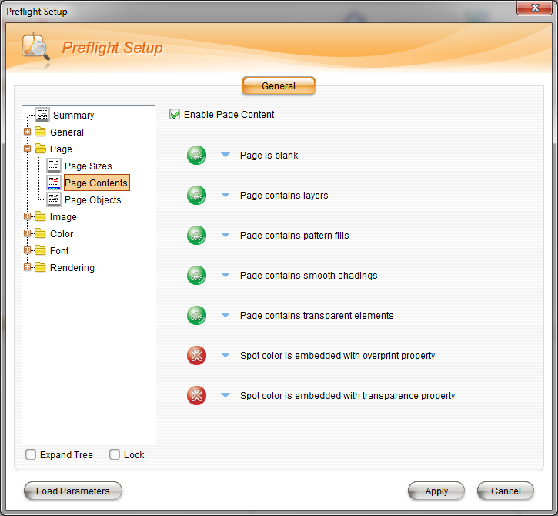

- Add Free Screen, which supports object-level screening.
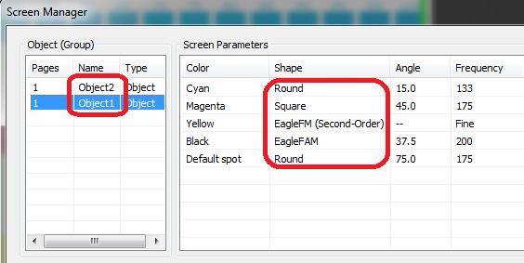

- Add printer drivers of Epson 4900, Canon iPF 650, 655, 750, 755, 815, 825, HP DesignJet Z3200, Z6100, T1200

- Check the problem when client starting, as following:
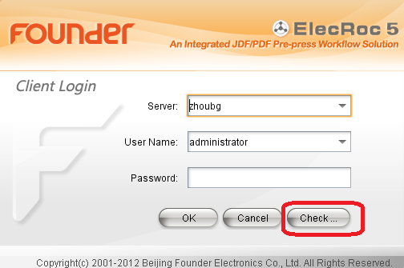

- In Preference, you can select: Disable the shared node or display jobs in X days in order to improve speed, as following:
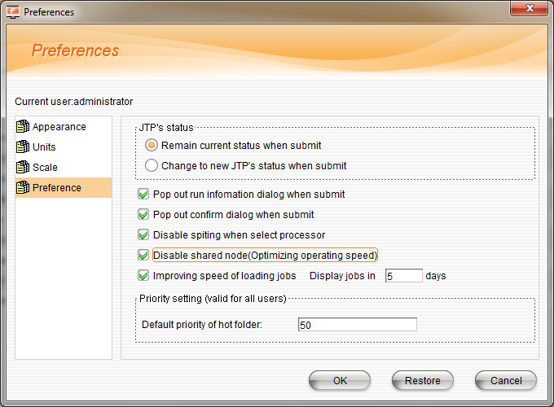

- Creating a new job from a saved ticket, as following:
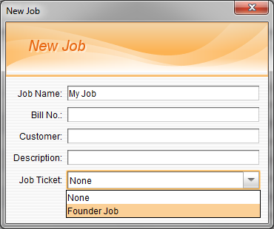

- Change some default settings, as following:
- Unselect Ignore Absent Font in PDF Generator Setup
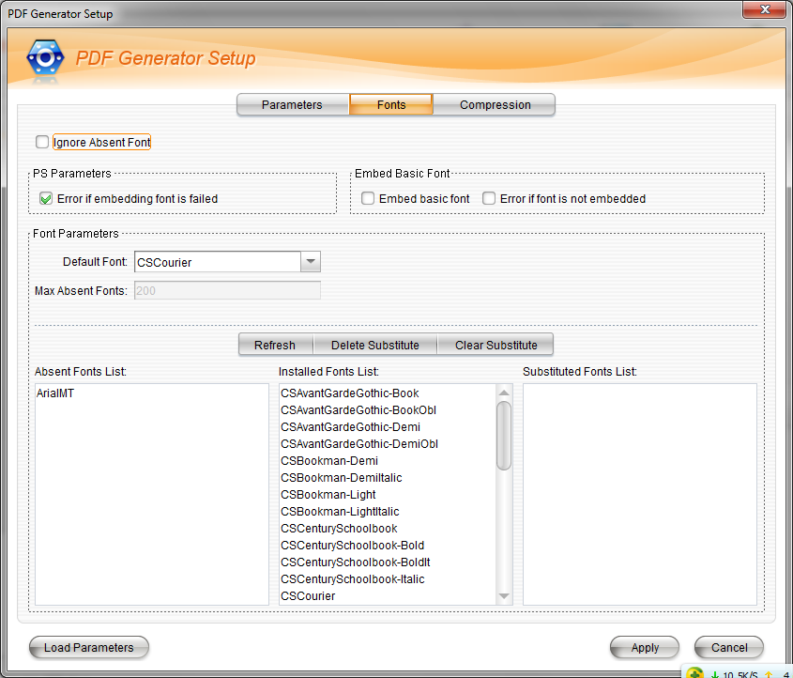
- Change the default Media Size to 2000mmX1188mm in PDF Rasterizer.
